20 Years of Energy Balance Observations on Antarctica using Automatic Weather Stations

Carleen Reijmer, Michiel Van den Broeke, Paul Smeets, and Wim Boot
Utrecht University, Institute for Marine and Atmospheric Research Utrecht, Physics and Astronomy, Utrecht, Netherlands
(c.h.tijm-reijmer@uu.nl)

Since 1995, the Institute for Marine and Atmospheric research, Utrecht (IMAU) operates Automatic Weather Stations (AWS) on Antarctica. A total of 17 stations of which three located on the Larsen ice shelf, one on Berkner Island, and 13 in Dronning Maud Land (DML), are or have been operational. Throughout time various types of IMAU design AWS were applied and will be presented. In accord, we discuss the current status of our AWS ARGOS transmissions and the availability of these data in GTS. An overview of all operational and previous IMAU AWS in Antarctica is given in Figure 1 including a list. A list of all AWS including live ARGOS data can be found at our website: http://www.projects.science.uu.nl/iceclimate/aws/antarctica.php.
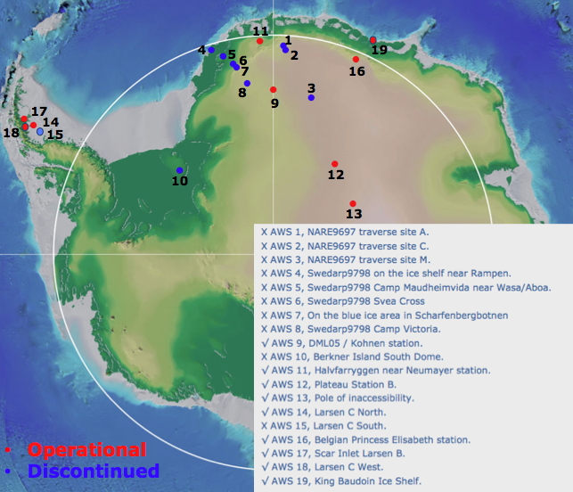
Figure 1. All operational and previous AWS from the IMAU in Antarctica.

Part of the records obtained between 1995 and 2013 are fairly complete and between 4 and 14 years long. The observed quantities include air temperature, relative humidity, wind speed, air pressure and incoming and outgoing short- and longwave radiation. The data from 9 stations are used to calculate the surface turbulent heat fluxes and to study the temporal and spatial variability of meteorological quantities and the surface energy budget. The longest time series show a trend towards higher annual average temperatures over the past 15 years similar to the trends found by Muto et al. (2011). In Figure 2 an example of the temporal variability of annually averaged temperature is shown for three time series in Dronning Maud Land (DML). The largest temperature change is occurring in DML on the Plateau (i.e. S9).
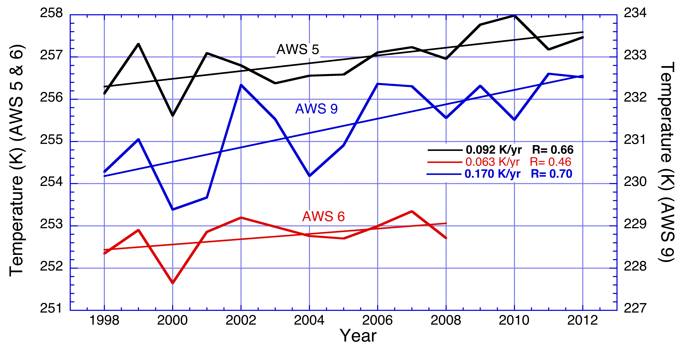
Figure 2. The temporal variability on annual time scales for three sites with the longest records (>8 years) in DML.

The annual mean net radiation is negative on all sites and the near-surface air is on average stably stratified giving rise to a positive sensible heat flux that is smallest at the Antarctic Plateau and largest in the escarpment region (Figure 3).
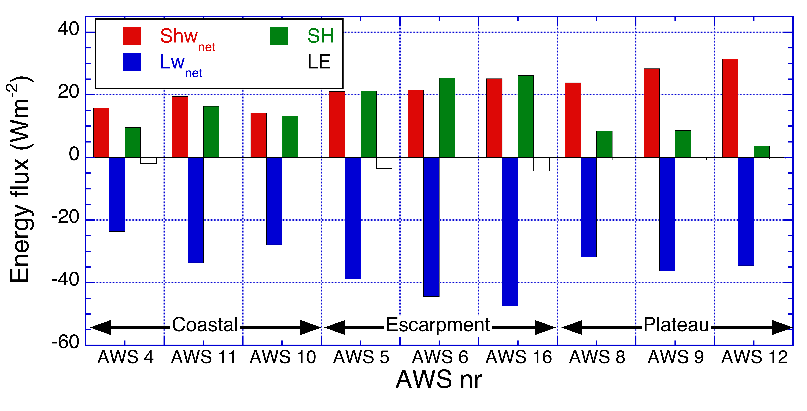
Figure 3. The surface energy balance components for 9 different IMAU AWS.

The negative net radiative flux is largely balanced by a positive sensible heat flux while the latent heat flux on average indicates a small net mass loss through sublimation. The spatial variations reflect differences in elevation, cloud cover and wind speed.

The individual fluxes show large inter-annual variability (Figure 4). For location S9 the annual mean fluxes show a trend towards less negative net radiation, smaller sensible heat flux and larger latent heat flux. However, these trends are not significant due to the uncertainty in the observations and the method used to calculate the turbulent fluxes.

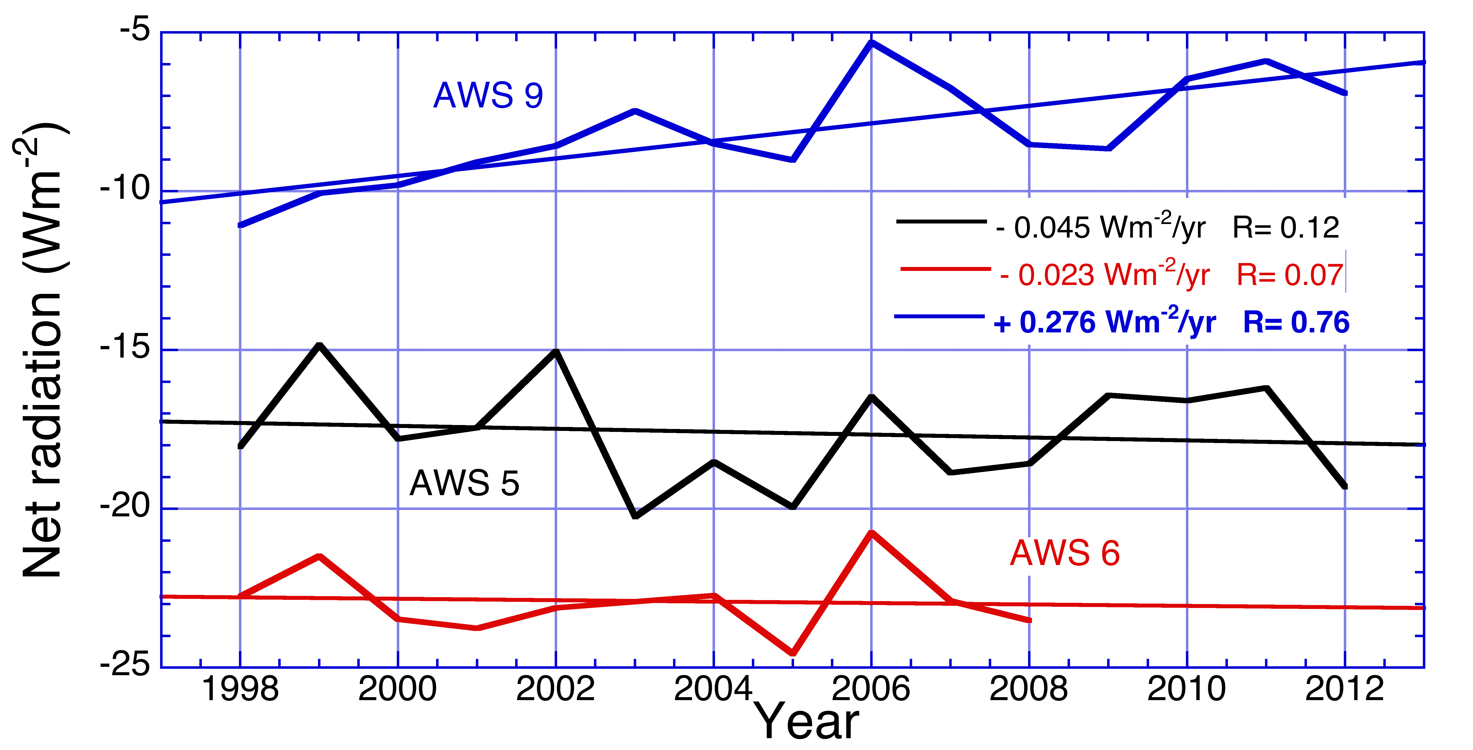
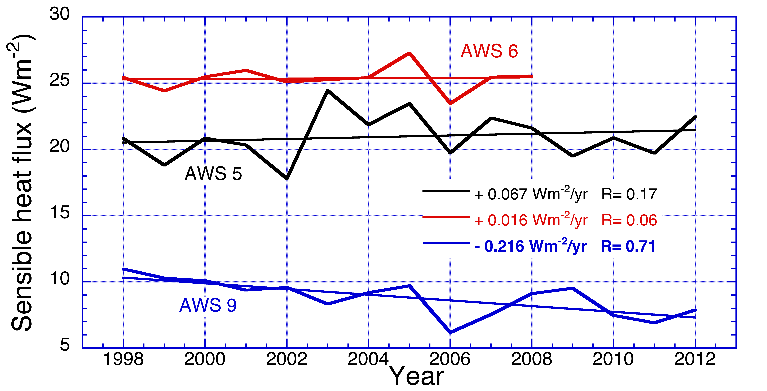
Figure 4. Annual mean net radiation and sensible heat fluxes for three stations in DML.

References
Muto et al., 2011. Geophys. Res. Lett., 38, L15502, doi:10.1029/2011GL048086
Van den Broeke et al., 2005. Int. J. Climatol., 25, 1081-1101.

